Question 29:

CODE:

%{

#include <stdio.h>

%}

%%

"<"[^">"]+">" { printf("HTML Tag: %s\n", yytext); } /* Match HTML tags */

.|\n { /* Ignore everything else */ }

%%

int main() {

yylex();

return 0;

}

int yywrap() {

return 1;

}

OUTPUT:

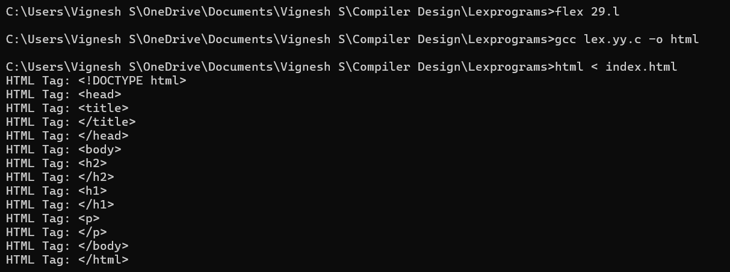

Question 30:

CODE:

%{

#include <stdio.h>

int line_no = 1;

%}

%%

.* { printf("%d: %s\n", line_no++, yytext); } /* Add line numbers to each line */

%%

int main() {

yylex();

return 0;

}

int yywrap() {

return 1;

}

OUTPUT:

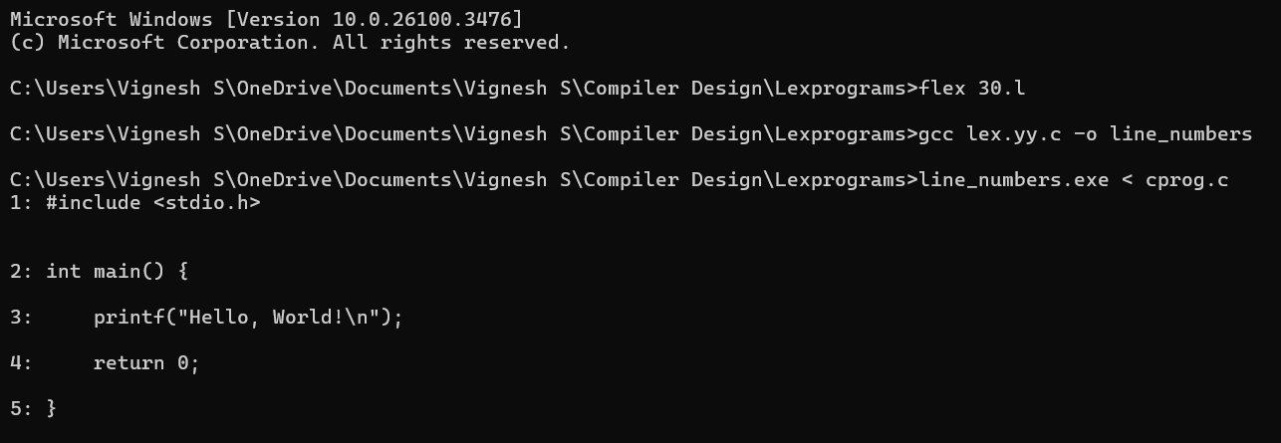

Question 31:

CODE:

%{

#include <stdio.h>

FILE *fout;

int comment_count = 0;

%}

%%

"//".* { comment_count++; } /* Count single-line comments */

"/*"([^*]|\*+[^*/])*\*+"/" { comment_count++; } /* Count multi-line comments */

.|\n { fputc(yytext[0], fout); } /* Write everything else to output file */

%%

int main() {

fout = fopen("output.c", "w");

if (!fout) {

printf("Error opening file!\n");

return 1;

}

yylex();

fclose(fout);

printf("Number of comment lines removed: %d\n", comment_count);

return 0;

}

int yywrap() {

return 1;

}

OUTPUT:

